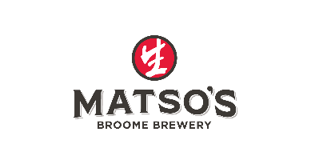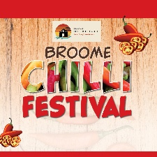

Competition Entry:
Entrant Name: ………………………………………………………………………………………………………………
Phone Number: …………………………………………………………………………………………………………….
Email address: ……………………………………………………………………………………………………………….

Category entering (if entering more than 1, fill out form for each category)

Jerky Condiment Dessert

Ingredients: this is for allergies – we do not want measurements as to keep your recipes safe and secret
………………………………………………………………………………………………………………………………………
………………………………………………………………………………………………………………………………………
………………………………………………………………………………………………………………………………………
………………………………………………………………………………………………………………………………………
Cost per entry: $20 payable by EFT
EFT payments to Broome Lotteries House
BSB: 016-554
Acc: 657756857
**please note on the transaction, your full name and chilli festival comp entry.
Cash and EFTPOS can be paid at Matso’s Broome Brewery before 12.30pm Thursday 23rd August 2026 (all payments will go to Broome Lotteries House) *no on the day payments*
**Rules and regulations for Broome Chilli Festival 2026 at Matso’s Broome Brewery**
- Cancelation policy – 100% refund will be given if the cancelation is more than 10 days (cut-off date is 15th August 2026) prior to the event. No cancellation refund will be given if within the 10 days leading up to the event.
- All ingredients MUST be listed to eliminate any potential allergies no measurements needed to protect your secrets.
- All foods must be stored correctly and comply with the Food Act 2008 and Food Standard Code before judging taking place – this is the responsibility of the entrant.
- Kimberley Accommodation Group will not be liable for any damages or losses incurred during the event.

Declaration:
- In signing this entry form, I declare that I have read and agree with the Broome Lotteries House – Hosted by Matso’s Chilli festival 2026 Rules and Regulations, and to the best of my knowledge, all the information supplied by me is correct as to the date below (entry invalid if not signed)

Name: ………………………..………. Signature: …………………………………………Date: ………………….

